**Ignite Visitor System**

The **Ignite Visitor System** is comprised of a web-based scheduling app, iPad app, and name badge printer   
that allows Ignite staff to add members and visitors to check-in with a touchless experience.

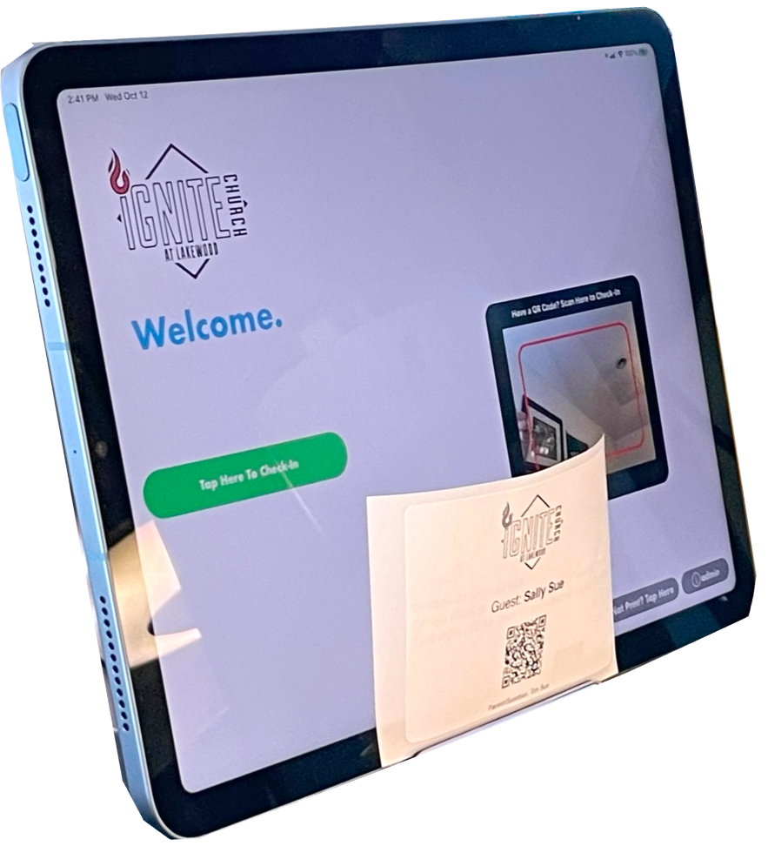

Contents

1. **Add a Member** 1
2. **View/Update Member** 1
3. **Check-In Using iPad App** 1
4. **Reports** 1

# **Add a Member**

Back to top

1. Go to <https://ignitevisitorsystem.github.io/>
2. Click on **Schedule Visitor**

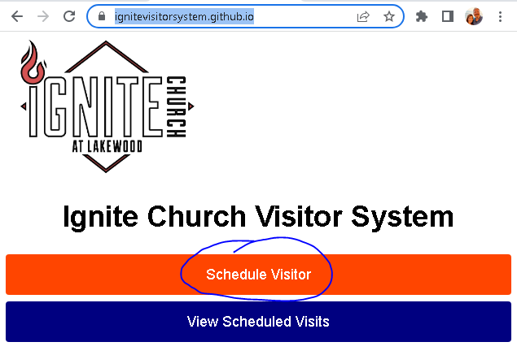

1. Completely fill-out ALL fields then Click on **Schedule Visitor**

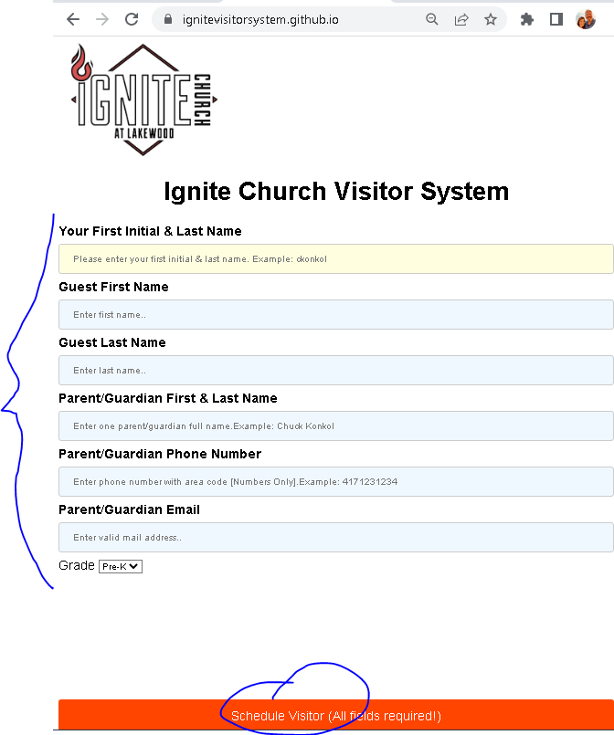

1. Create email to visitor
   1. Click link: **Click here to create email to guest**
   2. Edit email to personalize
   3. Send email (see below image)

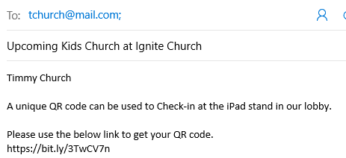

# **View/Update Member**

Back to top

1. Go to <https://ignitevisitorsystem.github.io/?all=yes>
2. Find member & click on the **click here** link (See image below)

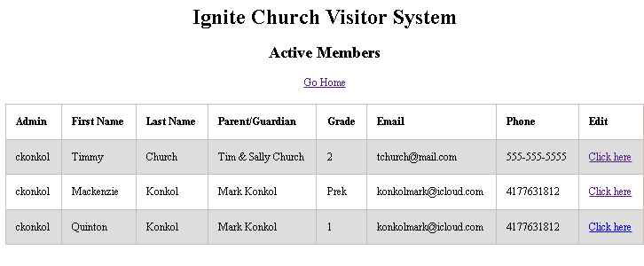

1. Update data: Edit data fields then click **Update Visit** button (see #1 in image below)
2. Make member active/in-active: Click on link below **Status:** (see #2 un image below)

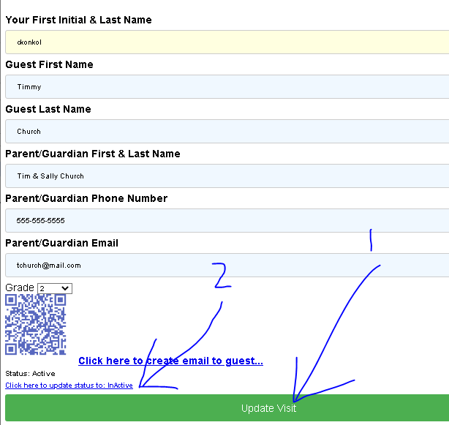

# **Check-In Using iPad App**

Back to top

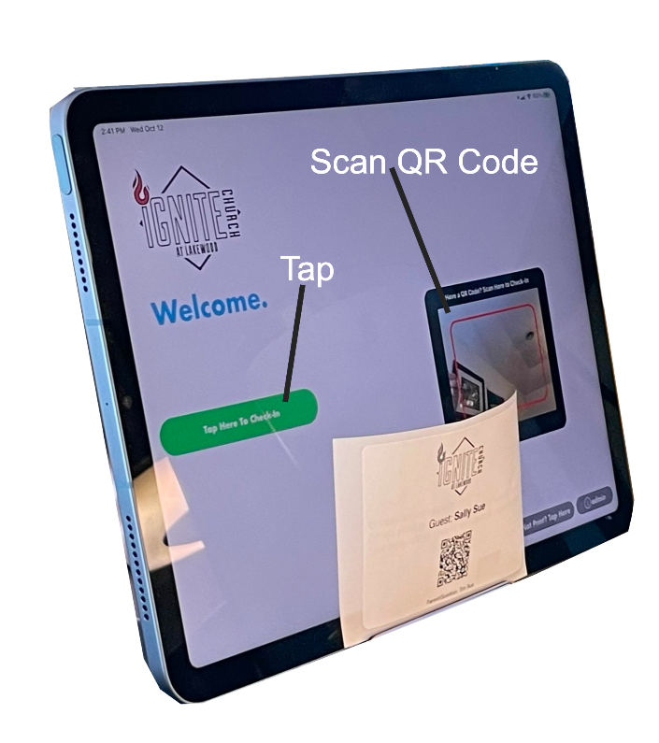

1. First-time user that did not get email from with link to QR code
   1. **Tap Here to Check-In** button
   2. Complete all fields
   3. Tap **Submit** button
   4. **Take photo of QR code for subsequent check-ins**
   5. Tap **Check-In** button
2. Subsequent Visits or users that received an email with link to QR code
   1. **Scan QR Code (Preferred Method)**. Retrieve name badge from printer   
      **OR**
   2. **Tap Here to Check-In** button
      1. Enter last name  
         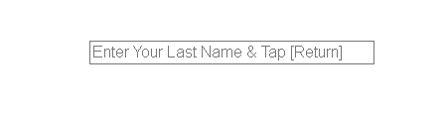
      2. Tap [Return] key to retrieve record
      3. Tap **Select** button  
         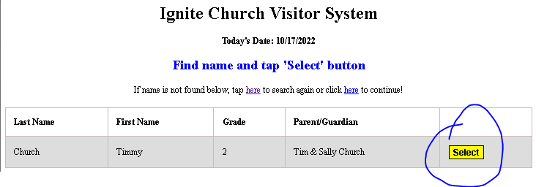
      4. Tap **Tap Here to Check-In** button
      5. Retrieve name badge from printer

# **Reports**

Back to top

1)    Check-in report by date: [ignitevisitorsystem.github.io/?all=today](https://ignitevisitorsystem.github.io/?all=today)

2)    Members

a.    Active members: [ignitevisitorsystem.github.io/?all=yes](https://ignitevisitorsystem.github.io/?all=yes)

b.    In-Active members [ignitevisitorsystem.github.io/?all=no](https://ignitevisitorsystem.github.io/?all=no)